
Contents
1. EXECUTIVE SUMMARY 4
2. INTRODUCTION 4
3. OBJECTIVES 4
4. DATASET DeSCRIPTION 5
i. DATASET OVERVIEW 5
ii. DATA PREPROCESSING 5
5. EXPLORATORY DATA ANALYSIS (EDA) 6
i. UNIVARATE ANALYIS 6
a. AGE DISTRIBUTION 6
b. OVERTIME 7
ii. BIVARIATE ANALYSIS 8
a. MONTHLY INCOME VS ATTRITION 8
b. OVERTIME VS ATTRITION 9
c. YEARS AT COMPANY VS ATTRITION 9
d. JOB ROLE VS ATTRITION 10
e. CORRELATION MATRIX AND HEATMAP 10
iii. OUTLIER DETECTION 12
6. MODELING 13
i. LOGISTIC REGRESSION 13
a. ACCURACY 13
b. AUC AND ROC 14
ii. LINEAR DISCRIMINANT ANALYSIS (LDA) 15
a. ACCURACY 16
b. AUC AND ROC 17
iii. K-NN NEAREST NEIGHBORS (KNN) 17
a. ACCURACY 17
b. AUC AND ROC 18
iv. NAIVE BAYES 19
a. ACCURACY 19
b. AUC AND ROC 20
v. RANDOM FOREST (BAGGING) 21
a. ACCURACY 21
b. AUC AND ROC 21
vi. GRADIENT BOOSTING 23
a. ACCURACY 23
b. AUC AND ROC 24
7. PERFORMANCE EVALUATION 24
8. BUSINESS INSIGHTS 26
9. CONCLUSION 26
10. RECOMMENDATIONS 26
11. APPENDICES 27
DETAILED CALCULATIONS 27
12. REFRENCES 27

EXECUTIVE SUMMARY
Employee attrition has become the problem that affects most organizations. It results in financial loss, productivity reduction, and stability challenges. The project objective was to create a prediction of employee attrition using supervised machine learning techniques. The data set is IBM HR Analytics Employee Attrition and the model utilized for the project is Logistic Regression, Linear Discriminant Analysis (LDA), K – Nearest Neighbors (KNN), Naïve Bayes, Randon Forest (Bagging), and Gradient Boosting.
The study was carried out in accordance with a structured Machine Learning Project plan. The results show that combined models, like Gradient Boosting, can predict employee attrition most accurately. The study can help in solving HR-related challenges.

INTRODUCTION
Employee attrition is the voluntary or involuntary departure of employees from an organization. When an organization experiences high level of attrition there are recruitment costs, workflow disruption, and a negative influence on employee morale. According to research on human resource analytics, predictive modeling can help an organization identify high-risk employees to take preventative measures.

OBJECTIVES
- To build predictive models on employee attrition
- To compare different machine learning models
- To use classification metrics to evaluate the models
- To create business intelligence on the models

DATASET DeSCRIPTION
- DATASET OVERVIEW
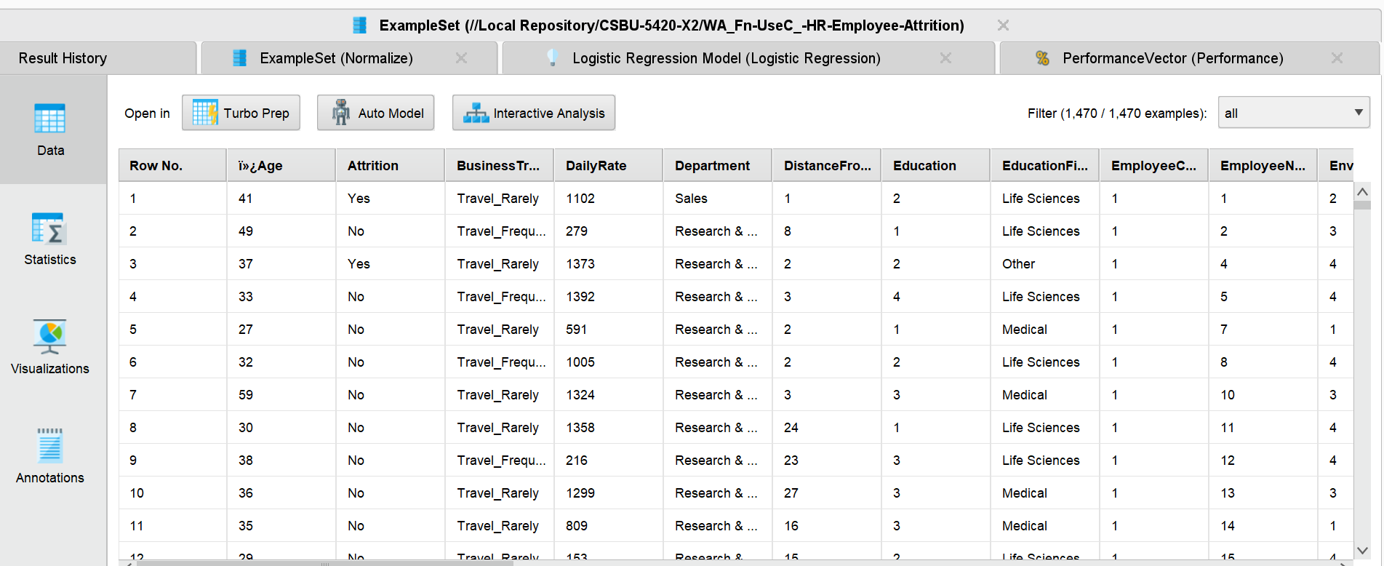
The dataset has 1470 observations and out of all 35 are independent variables. The variables are:
- Target variable has Attrition (Yes/No)
- Demographic Information (Age, Gender, Marital Status)
- Compensation Information has monthly Income, job level
- Job Information (Job Role, Department, Overtime)
- Performance Information has performance rating, years at company)

DATA PREPROCESSING
Preprocessing steps undertaken:
- Imported the CSV file using RapidMiner
- Specified “Attrition “as the label
- Used Nominal to Numerical operator
- Normalized the numerical attributes
- Split data into a ratio of 70:30 for training and testing.
- Used Cross Validation for model reliability

EXPLORATORY DATA ANALYSIS (EDA)

UNIVARATE ANALYIS

AGE DISTRIBUTION
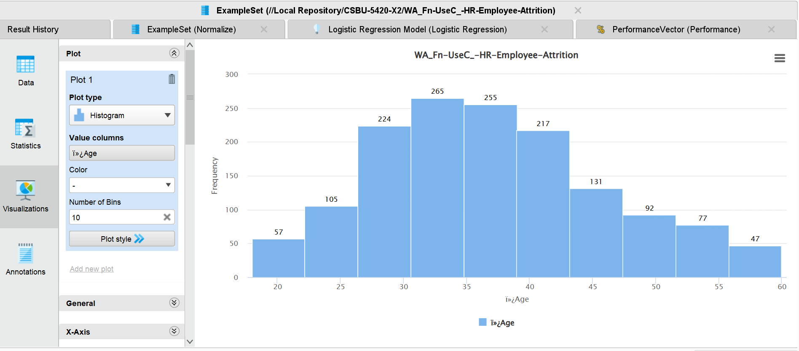
A histogram displays age distribution of employees. Most employees are between 28 to 40 years old and after 45 the number of employees starts to decrease, which means that there are just few older employees in the organization.
Attrition Distribution
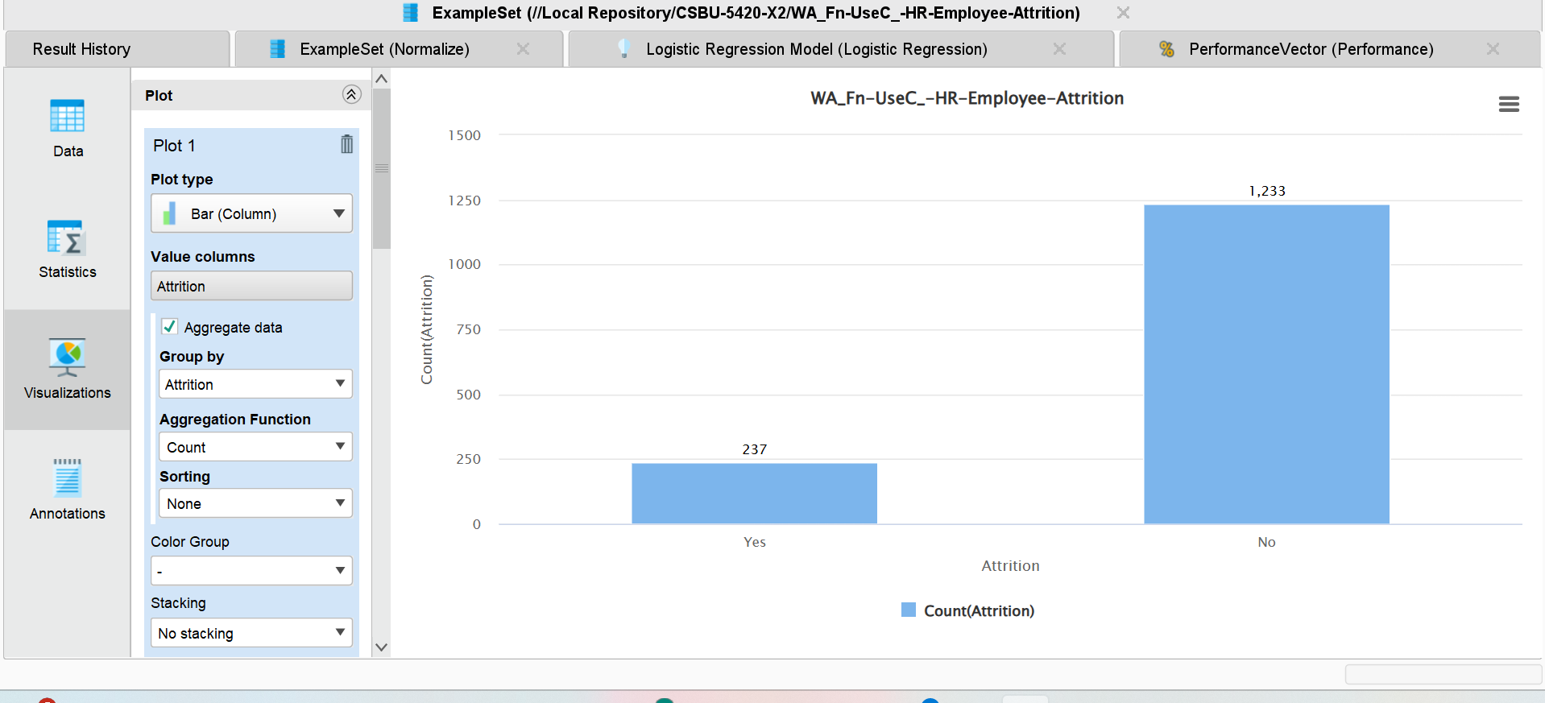
The bar chart illustrates the number of employees who left the company by Yes and those who stayed by No and the number of employees who left the company are 237 and those who are still in the company are 1233 which means that just few employees leave the company.

OVERTIME
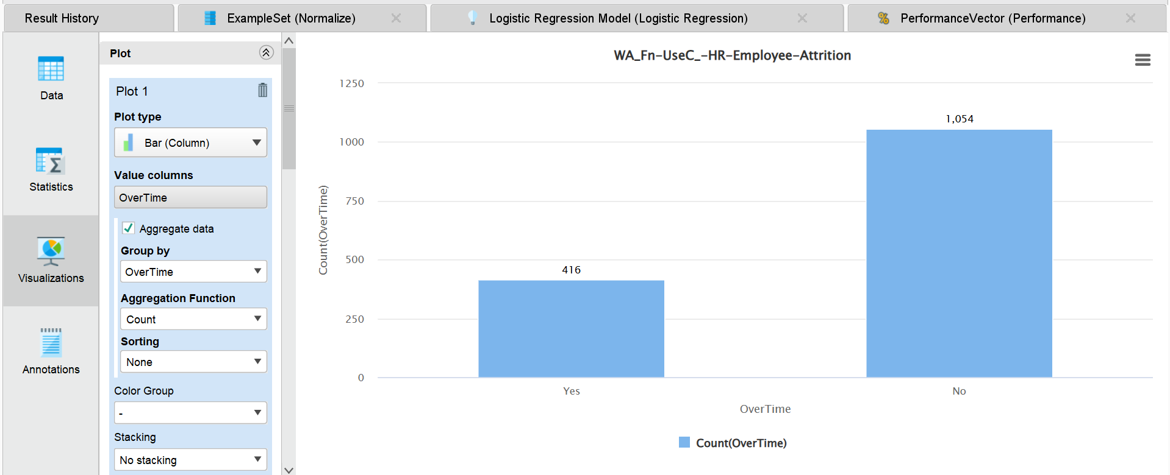 Among1,470 employees, 416 employees work overtime and 1,054 employees do not work overtime which means that most employees in this organization do not work overtime.

BIVARIATE ANALYSIS

MONTHLY INCOME VS ATTRITION
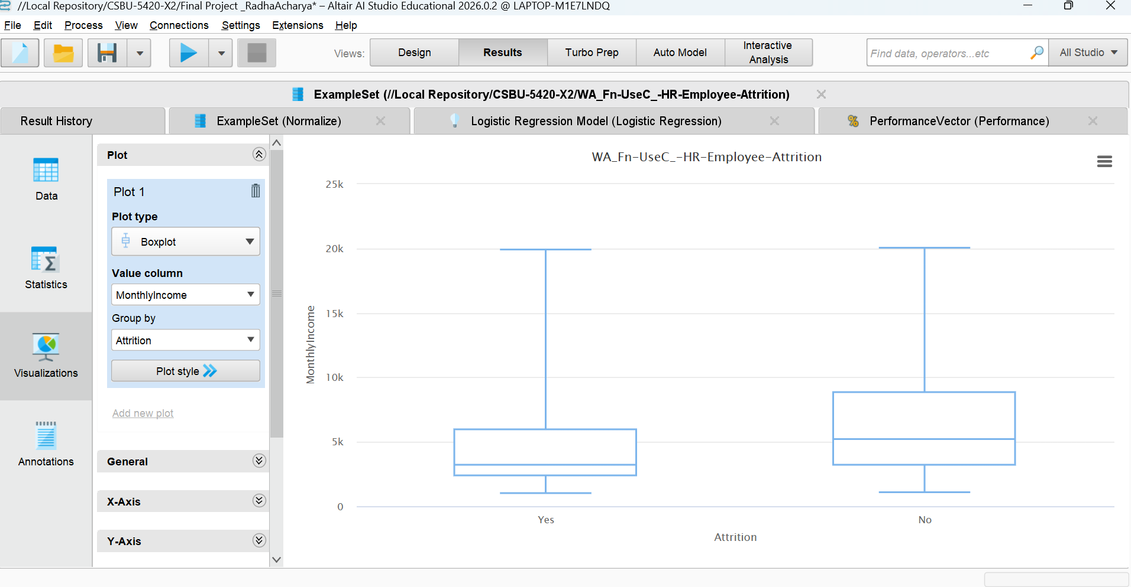
The median monthly salary of workers who left the company is lower than that of those who stayed as per the box diagram of Monthly pay vs Attrition. It indicates that employee monthly pay has a significant role in whether they decide to leave a company or not. However, there are few high-income anomalies, and these are real employees.

OVERTIME VS ATTRITION
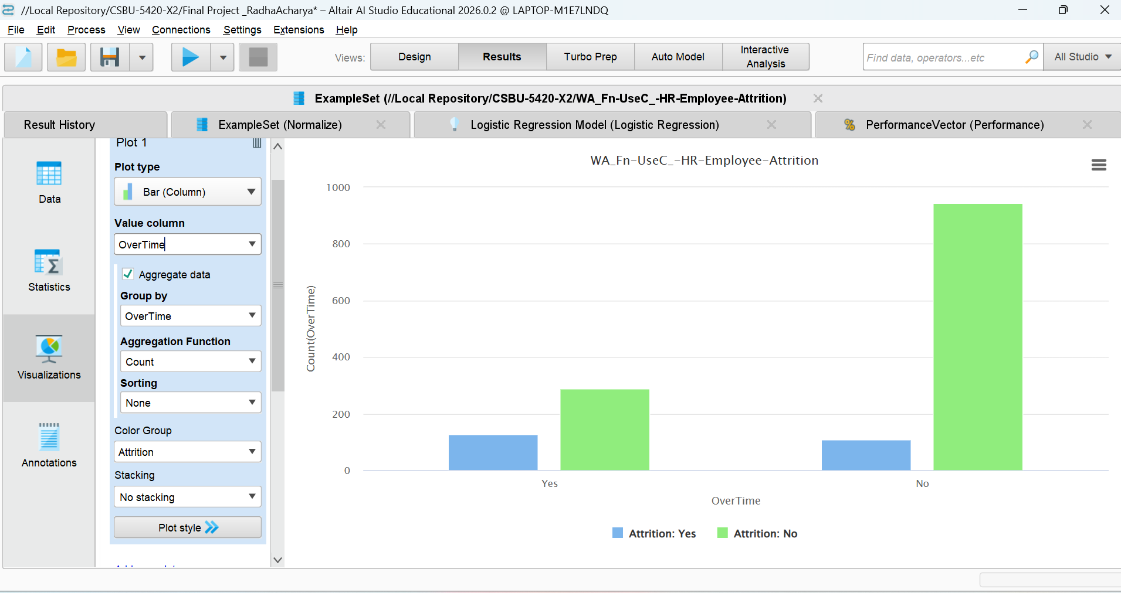
Although the number of employees not working overtime is high, the proportion of attrition is larger among employees working overtime.

YEARS AT COMPANY VS ATTRITION
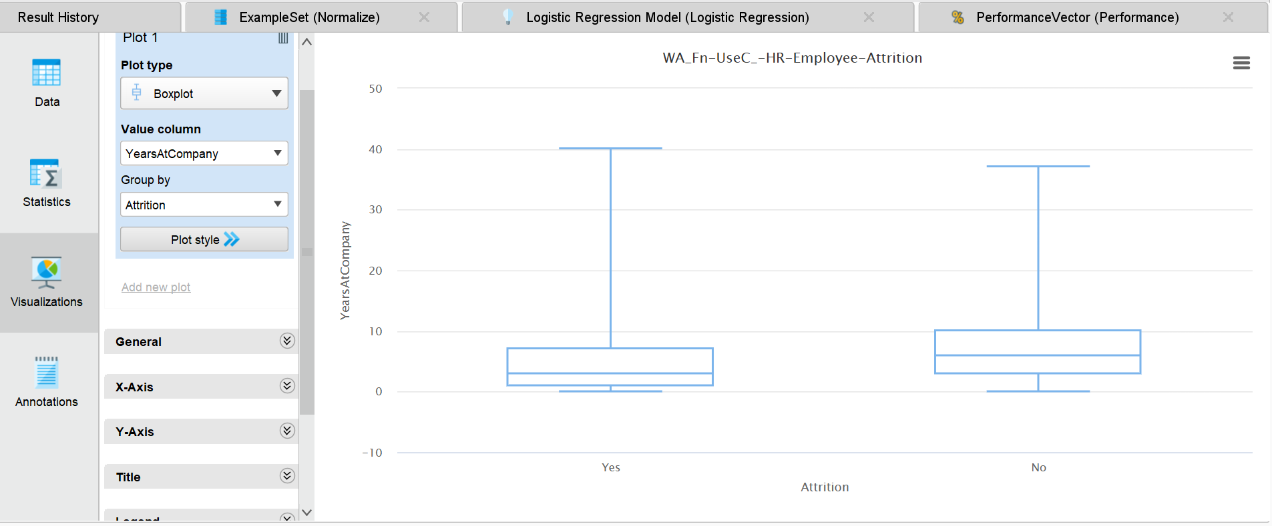
The boxplot compares the Years at Company with Attribution. The box-plot chart shows that employees who left the company have fewer years of services than those who stayed in the company and it shows negative relationship between two variables. As the newer employees in the company are the ones that tend to leave the company.

JOB ROLE VS ATTRITION
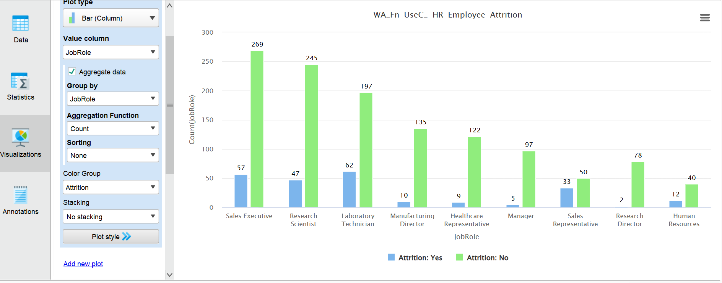
The group bar chart indicates that the highest rate of attrition is from the category of Laboratory Technicians and Sales Executives. Managerial and HR positions display lower rates of attrition which means that operational roles are experiencing more job dissatisfaction.

CORRELATION MATRIX AND HEATMAP

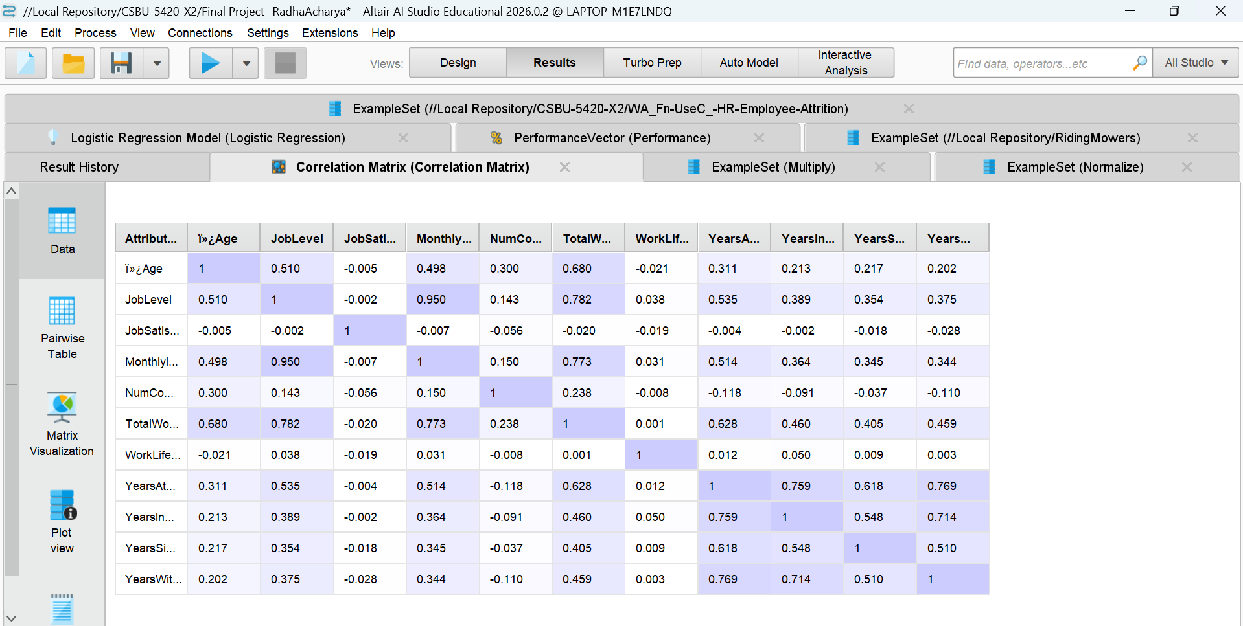
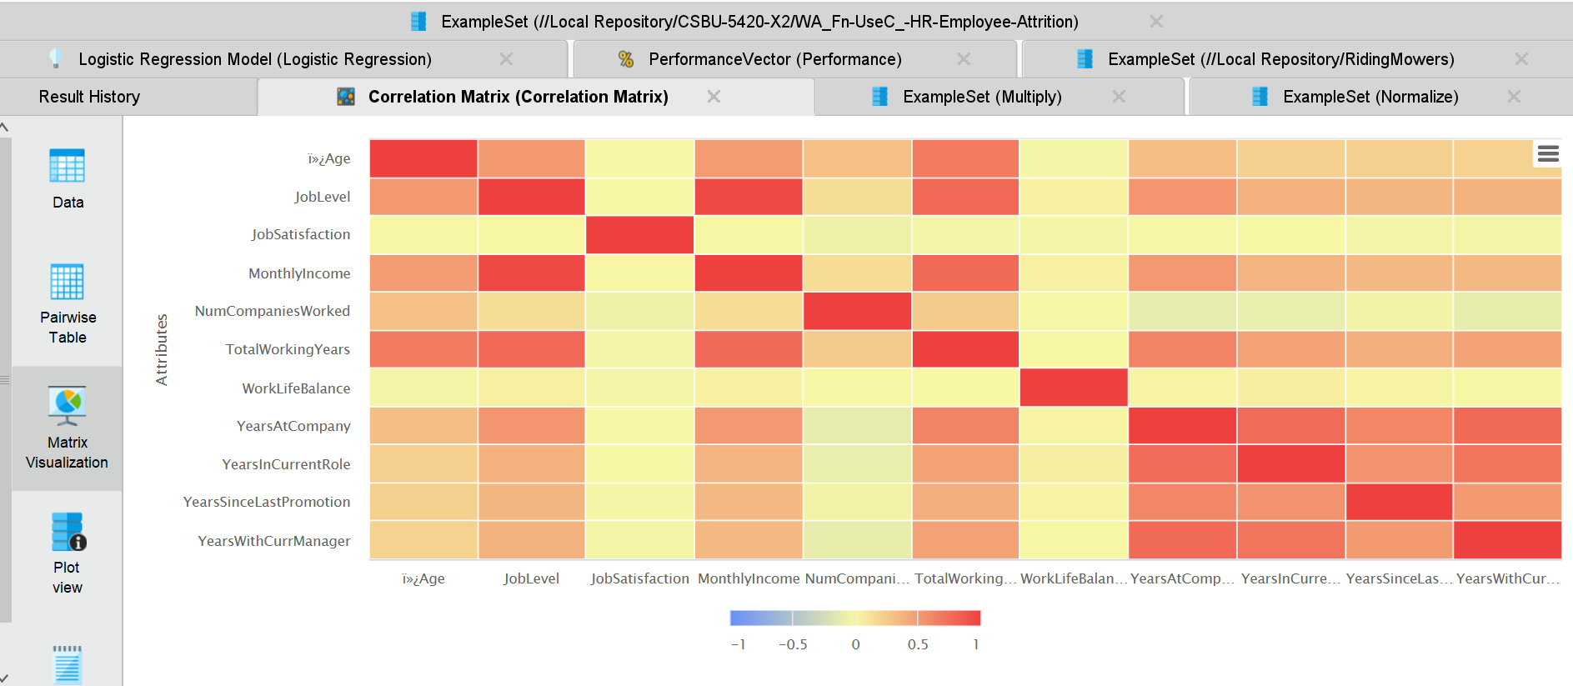
As the correlation matrix is used to perform bivariate analysis for numerical variables. A very high positive correlation exists between the two variables, Job Level and Monthly Income, at 0.950. Strong correlation exists between the two variables, Total Working Years and Monthly Income, at 0.773, and between the two variables, Total Working Years and Years at Company, at 0.628.

OUTLIER DETECTION
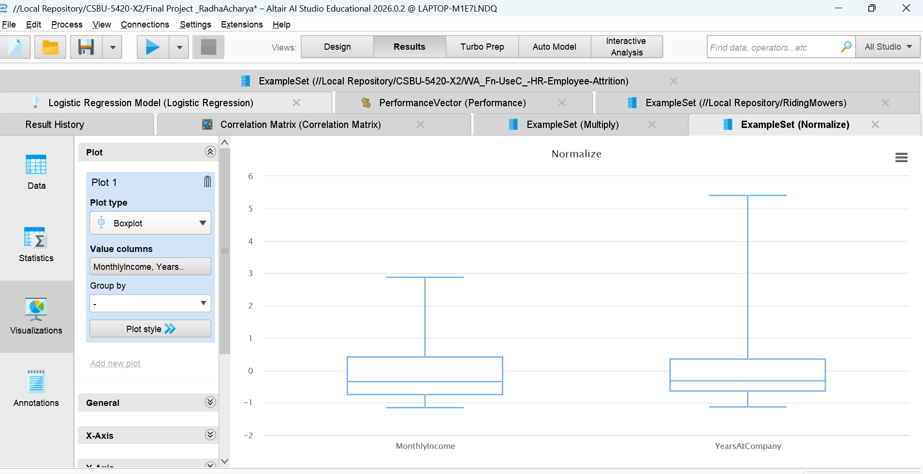
This boxplot illustrates the distribution of the normalized features Monthly Income and Years at Company. We see variability and outliers in these features. As we would expect lower income and shorter company tenure to correspond with increased turnover, these features are significant in our model.

MODELING

LOGISTIC REGRESSION

ACCURACY
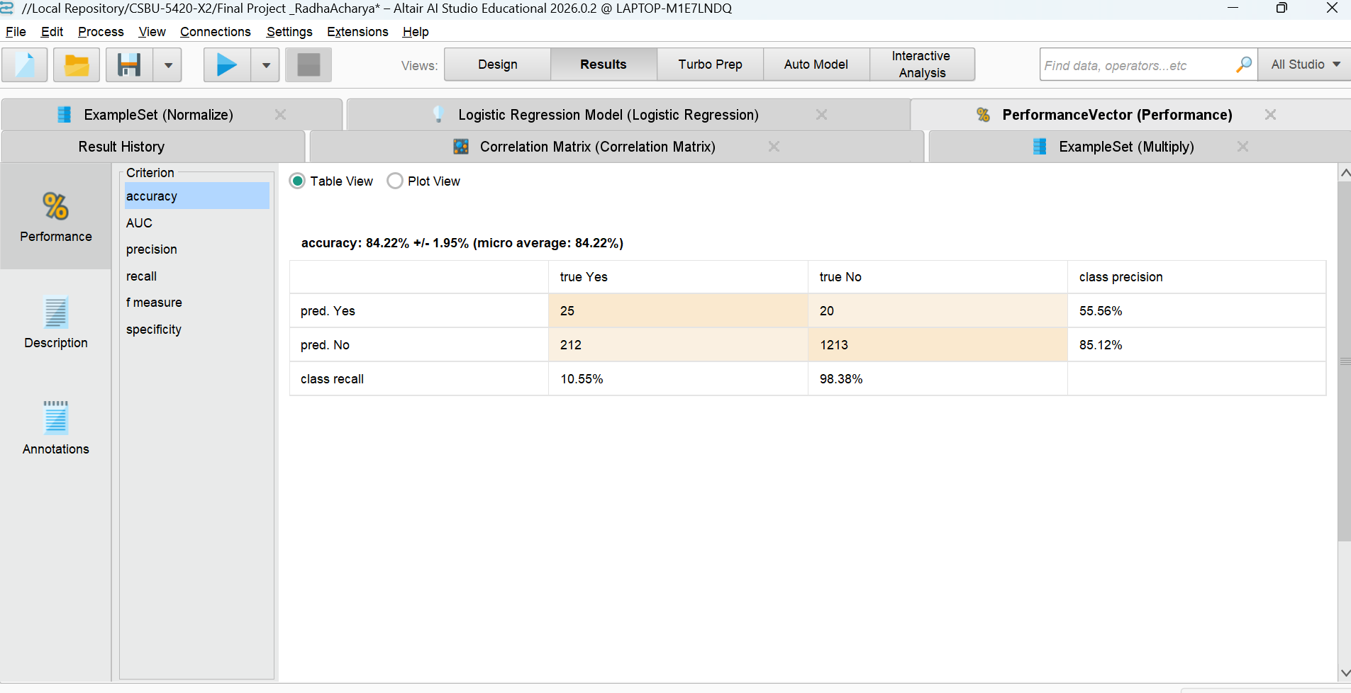
The Logistic Regression model has the accuracy of 84.22 % and the model correctly predicts 25 employees who left the company among 237 employees. The recall for class attrition was low at 10.55 %. Though the model performed exceptionally well on employees who stayed at the company (98.38% recall for class No’), its performance on employees who left the company was poor.

AUC AND ROC
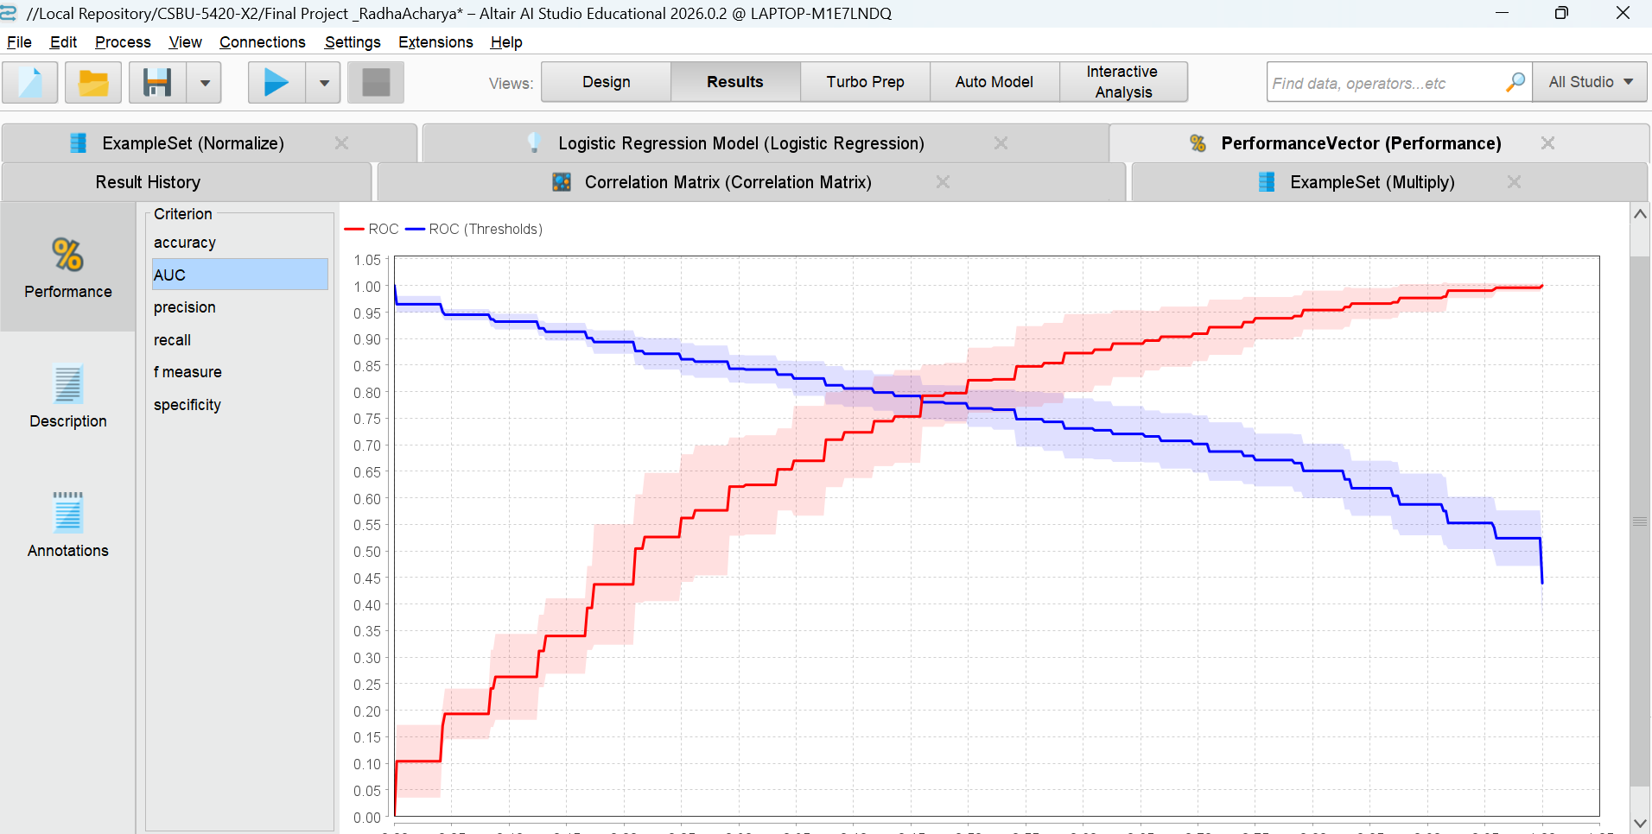
This chart is the ROC curve of Logistic Regression model, and a curve is diagonal which means that model is performing better than a random guess. AUC has the higher value which means that model is good at predicting the two classes.
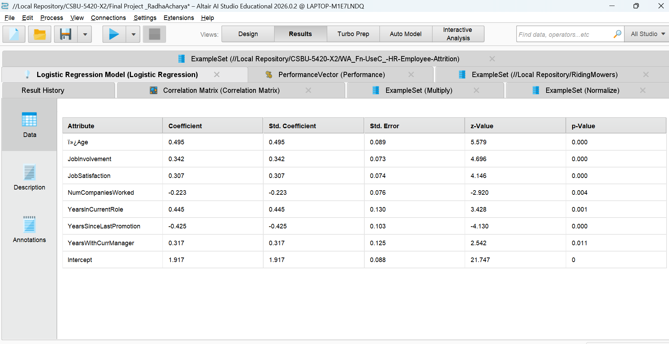
The logistic regression analysis found that Age, Job Involvement, Job Satisfaction, Number of Companies Worked, Years in Current Role, Years Since Last Promotion, and Years with Current Manager were significant predictors of employee attrition (p < 0.05). Among these, the effects of Age and the career progression factors were found to be the most significant predictors of employee attrition. This study found that employee retention is significantly related to the level of employee engagement in the organization. Similarly, highly corelated predictors are removed to improve the accuracy of the model.

LINEAR DISCRIMINANT ANALYSIS (LDA)
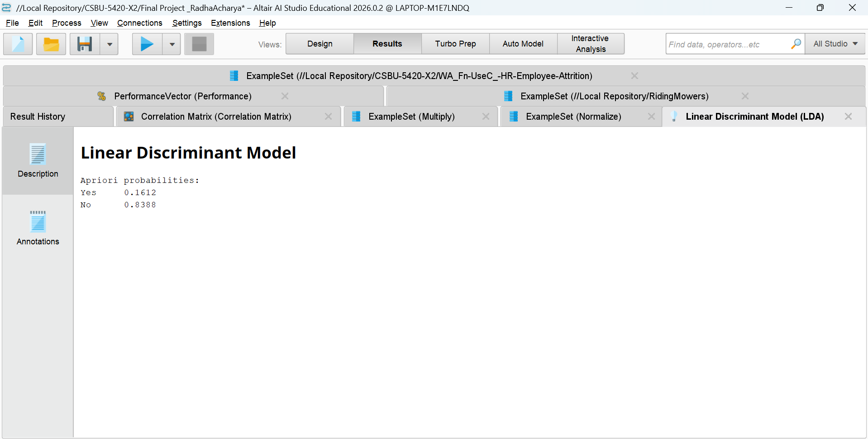

ACCURACY
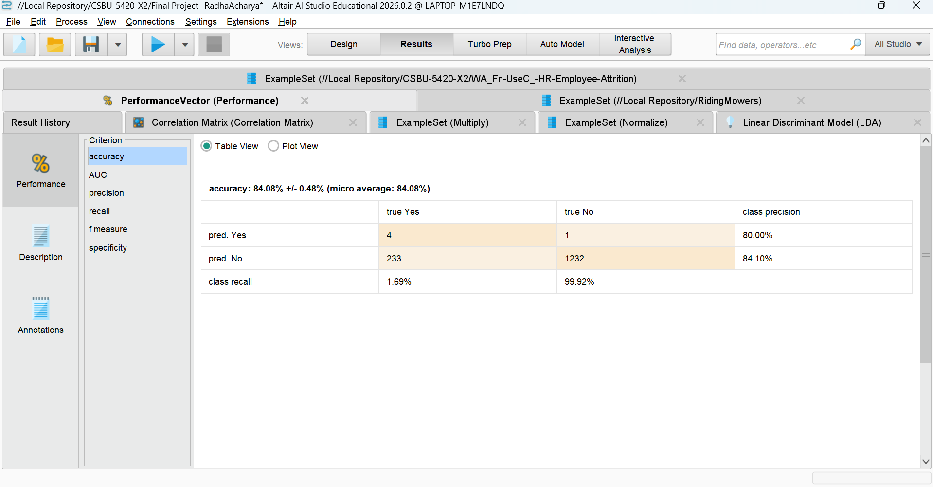
The accuracy of the model is 84.08%. Even though the model is good at predicting employees who stayed which is 99.92%, the model is also extremely poor in predicting employees who left the company which is 1.69%. Among the employees who left the company only 4 of them are correctly predicted and 233 are predicted wrong. Even though the model has extremely high accuracy it is biased towards majority class and the model is poor in predicting the employees who leave.

AUC AND ROC
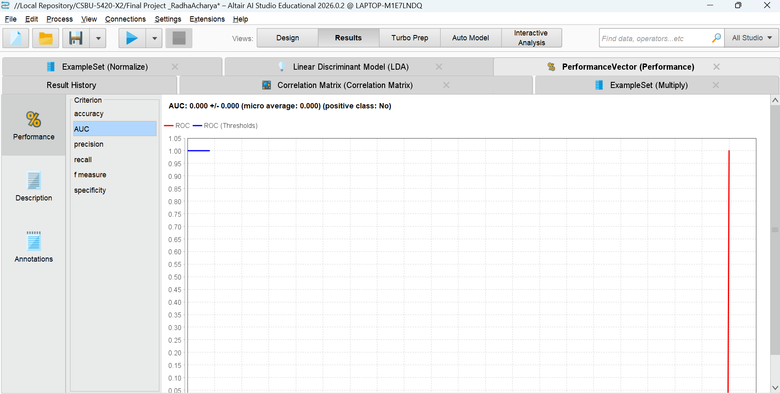
As AUC has a value of 0.000 which means the model is poor at predicting employee attrition.

K-NN NEAREST NEIGHBORS (KNN)

ACCURACY
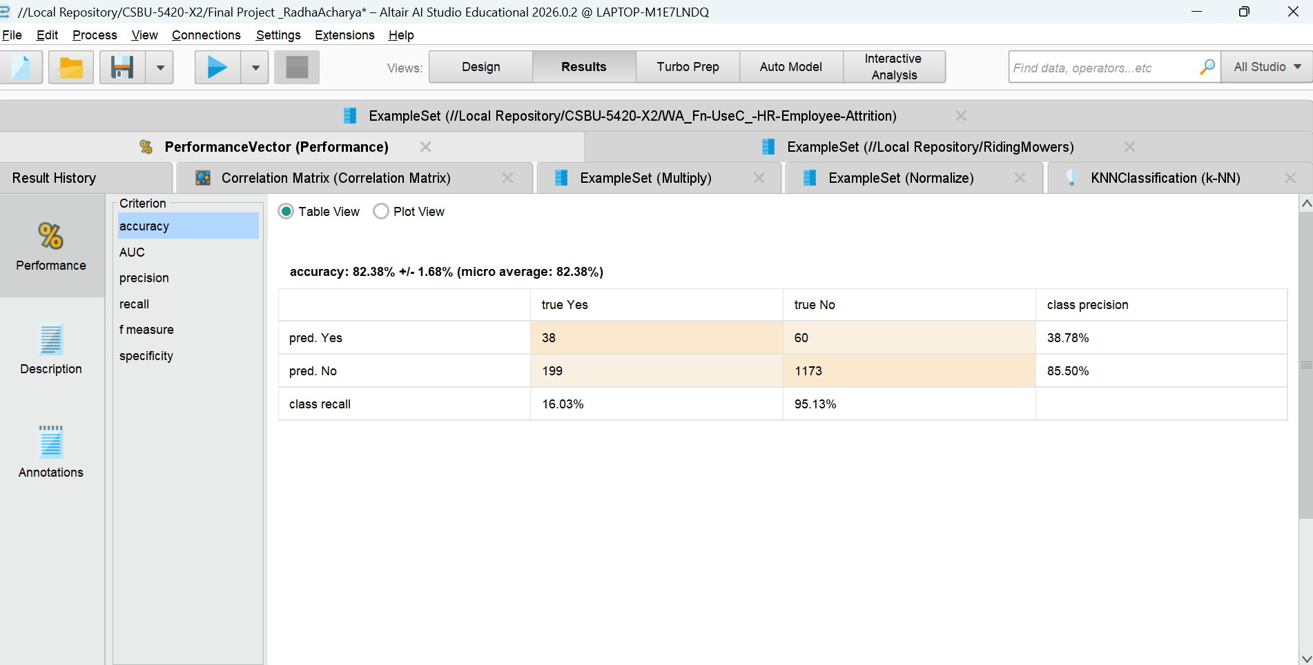
The KNN model has an accuracy of 82.38%, which is slightly lower than that of LDA. Yet, KNN has a better performance in detecting employees who left the company. The recall value for the “Yes” class, which represents Attrition, is 16.03%, which means that 38 employees are correctly detected as having left the company by the model, as opposed to very few employees detected by LDA. Even though there are 60 false positives and 199 false negatives, it can be observed that KNN has better sensitivity towards the minority class. Considering that employee attrition is the main concern in this analysis, it can be stated that KNN has a better performance than LDA.

AUC AND ROC
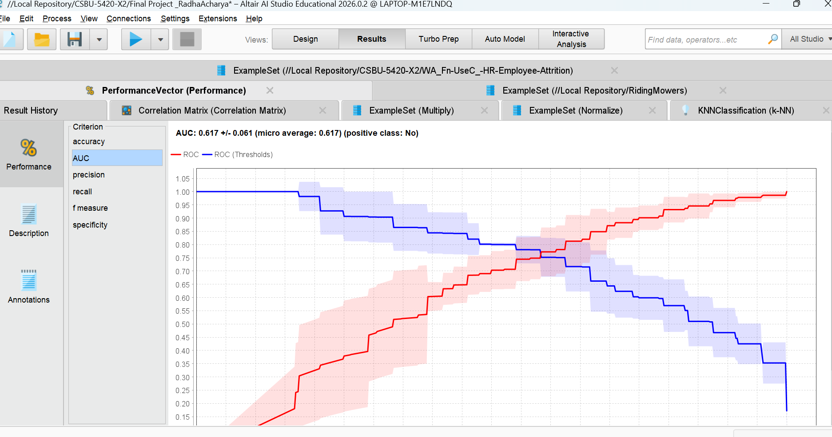
The KNN has AUC of 0.617, which shows that it has moderate predictive ability and even though it performed slightly better than LDA in detecting attrition cases, its discrimination power is still limited.

NAIVE BAYES

ACCURACY
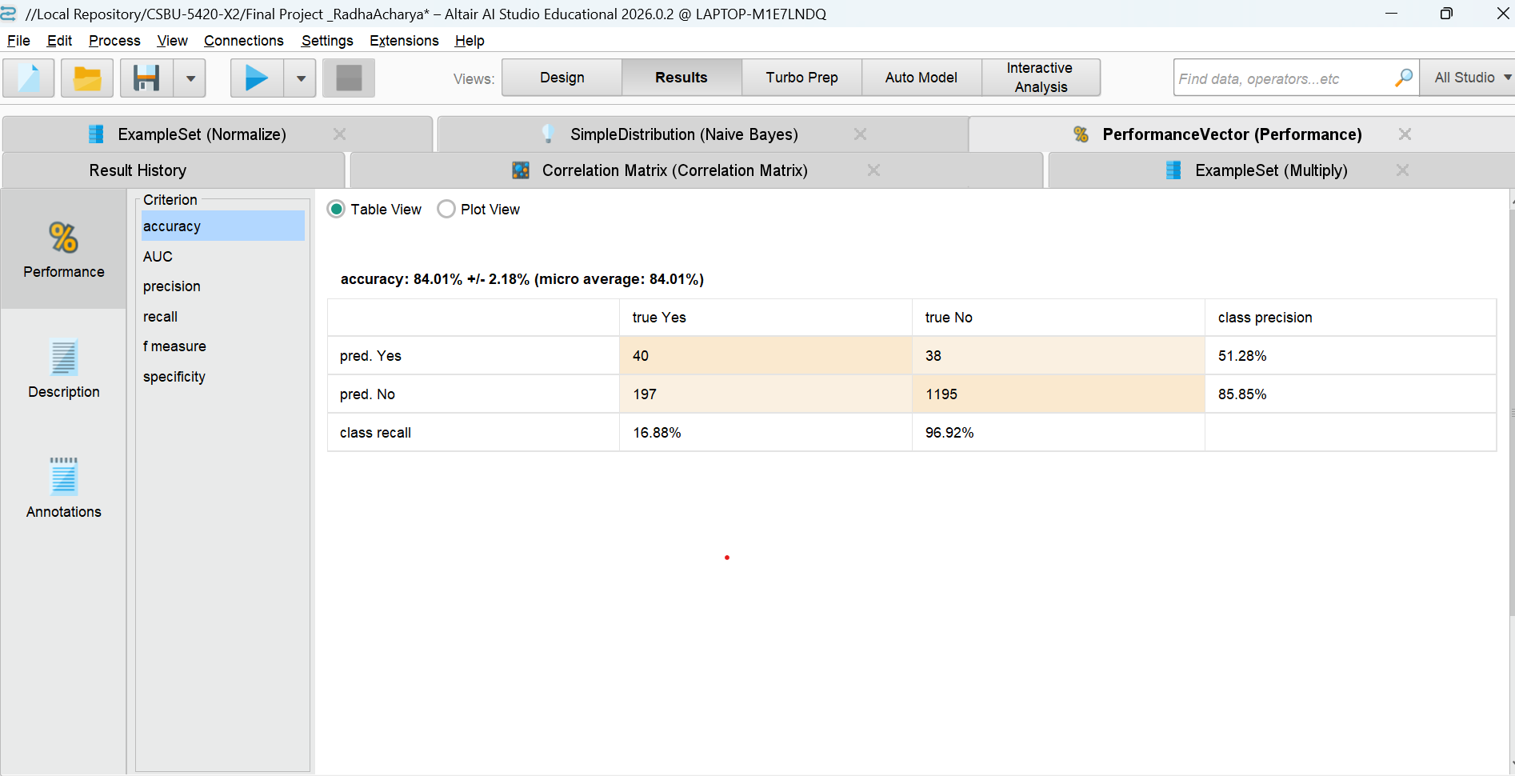
The accuracy of the Naïve Bayes model was found to be 84.01%, which is a good performance in terms of predicting employees who stayed. However, the model was able to correctly predict only 16.88% of employees who left, which is a low performance for the attrition class. This shows that the Naïve Bayes model is good at predicting the majority class but is not good at detecting employees that are likely to leave.

AUC AND ROC
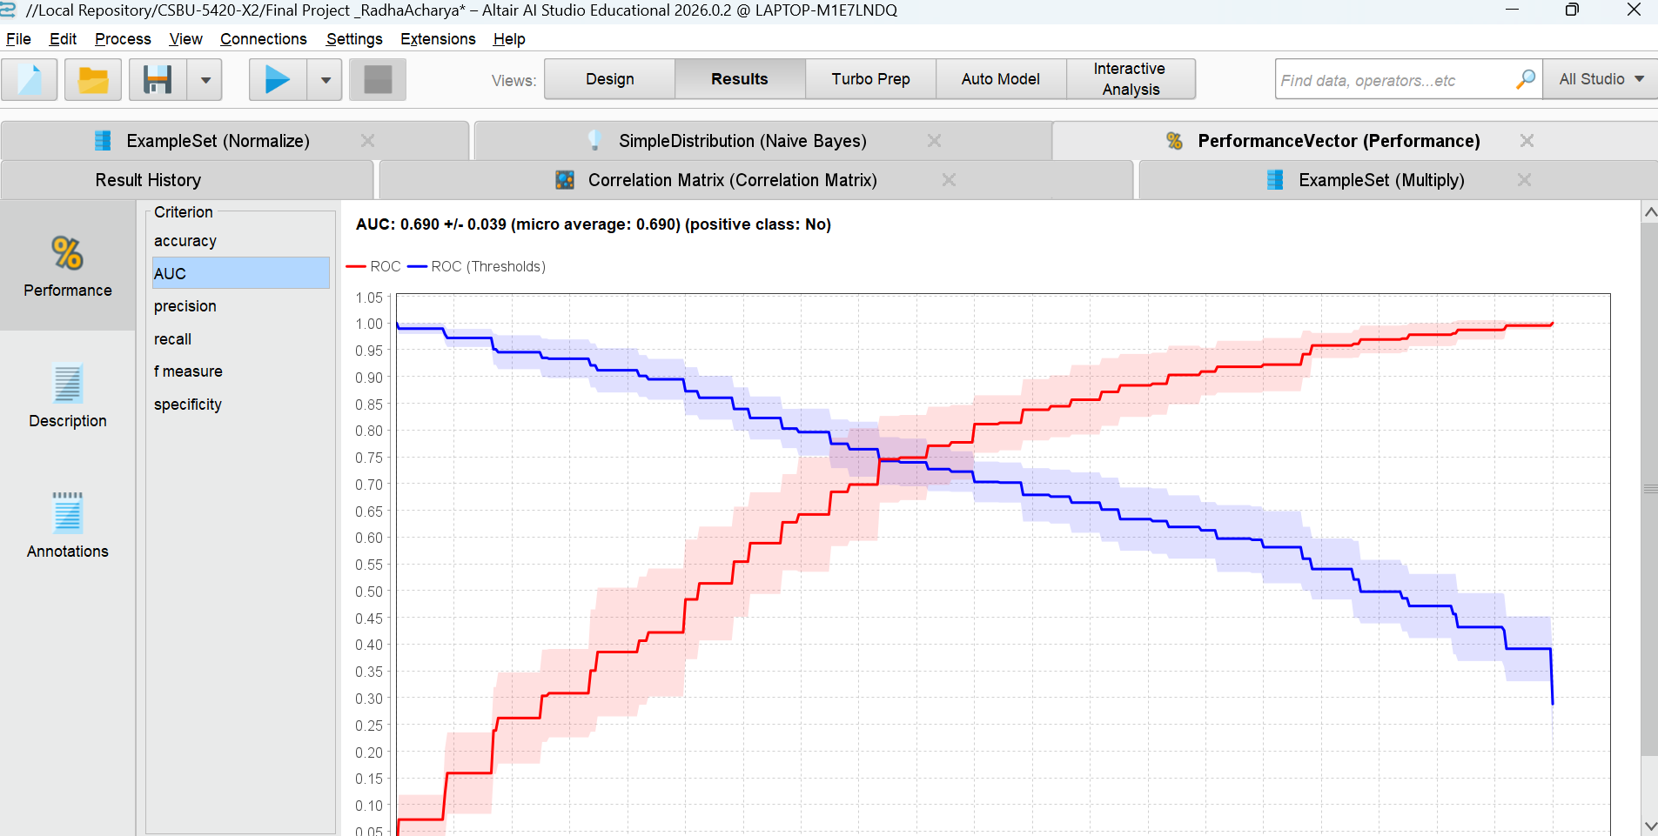
Naïve Bayes has AUC of around 0.690 which shows the average performance. Although Naïve Bayes has a better performance in compared to random guessing, ROC shows that model is poor at predicting ability. Naïve Bayes represents baseline performance compared to others and model is good at predicting employee turnover.

RANDOM FOREST (BAGGING)

ACCURACY
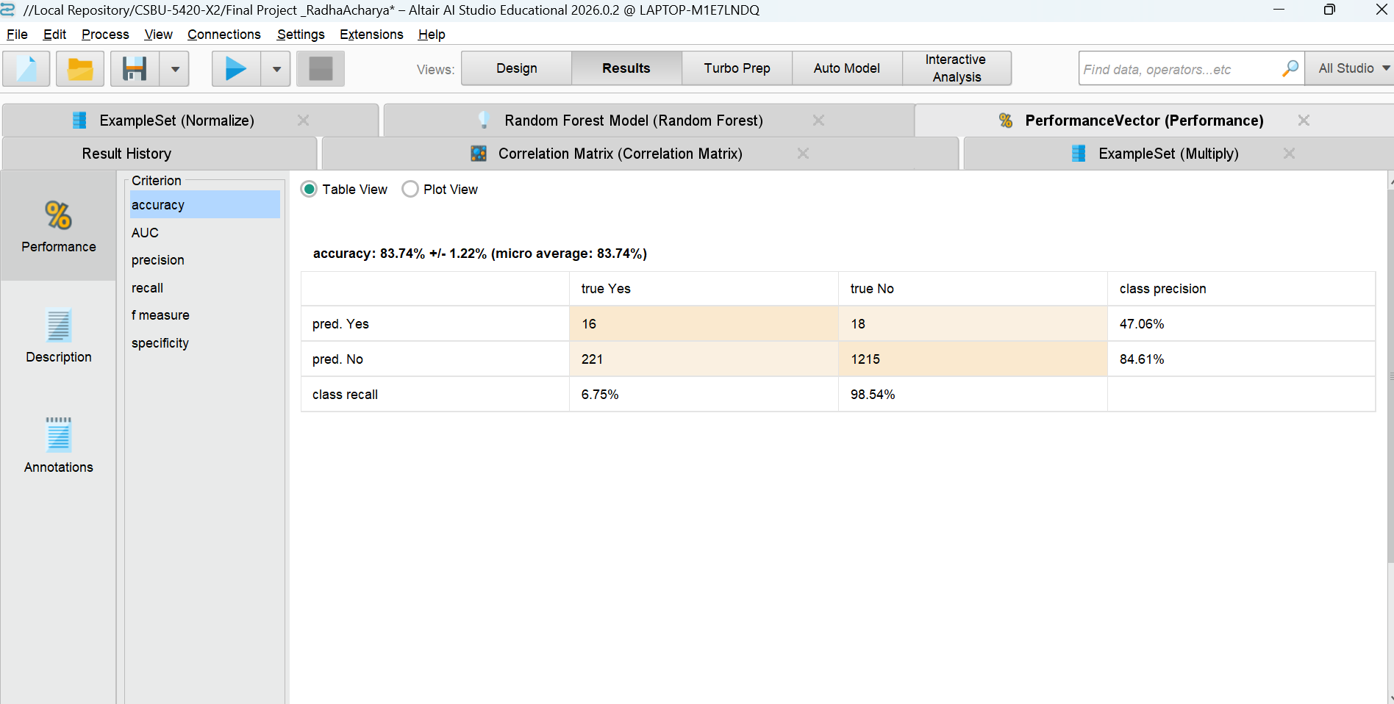
The Random Forest has an accuracy of 83.74 % and a strong performance for a classification model. Similarly, out of 237 employees the model was able to correctly classify 16 employees who left the company, which results in a very low recall value which is 6.75 %. Random Forest Model is extremely good at classifying employees who stayed at the company, which is 98.54% but the model didn’t do well at classifying employees who are at risk of leaving the company.

AUC AND ROC

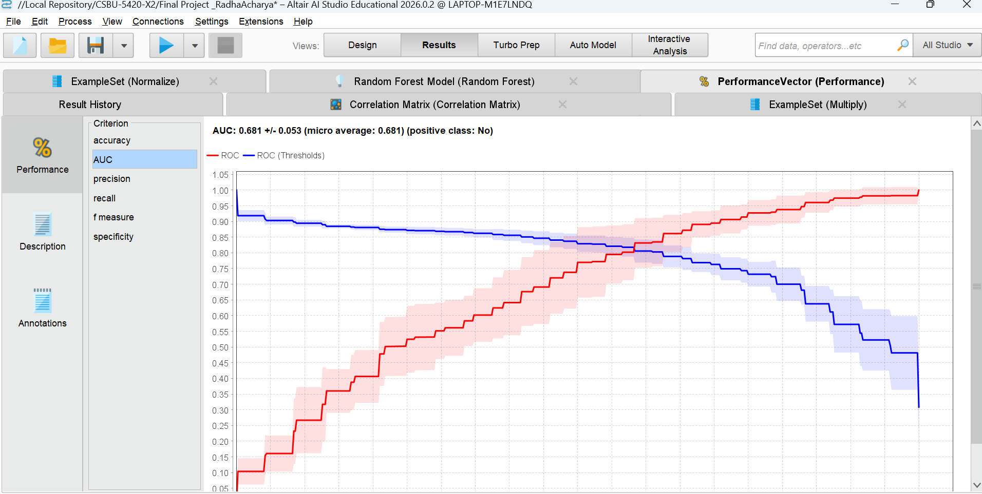
The Random Forest has AUC of 0.681 which means that the model can moderate discrimination ability. Even though the model performs better than Randon guessing the ROC curve implies that model has a limited class separation. Hence the Random Forest model is biased towards predicting the employees who will stay.

GRADIENT BOOSTING

ACCURACY
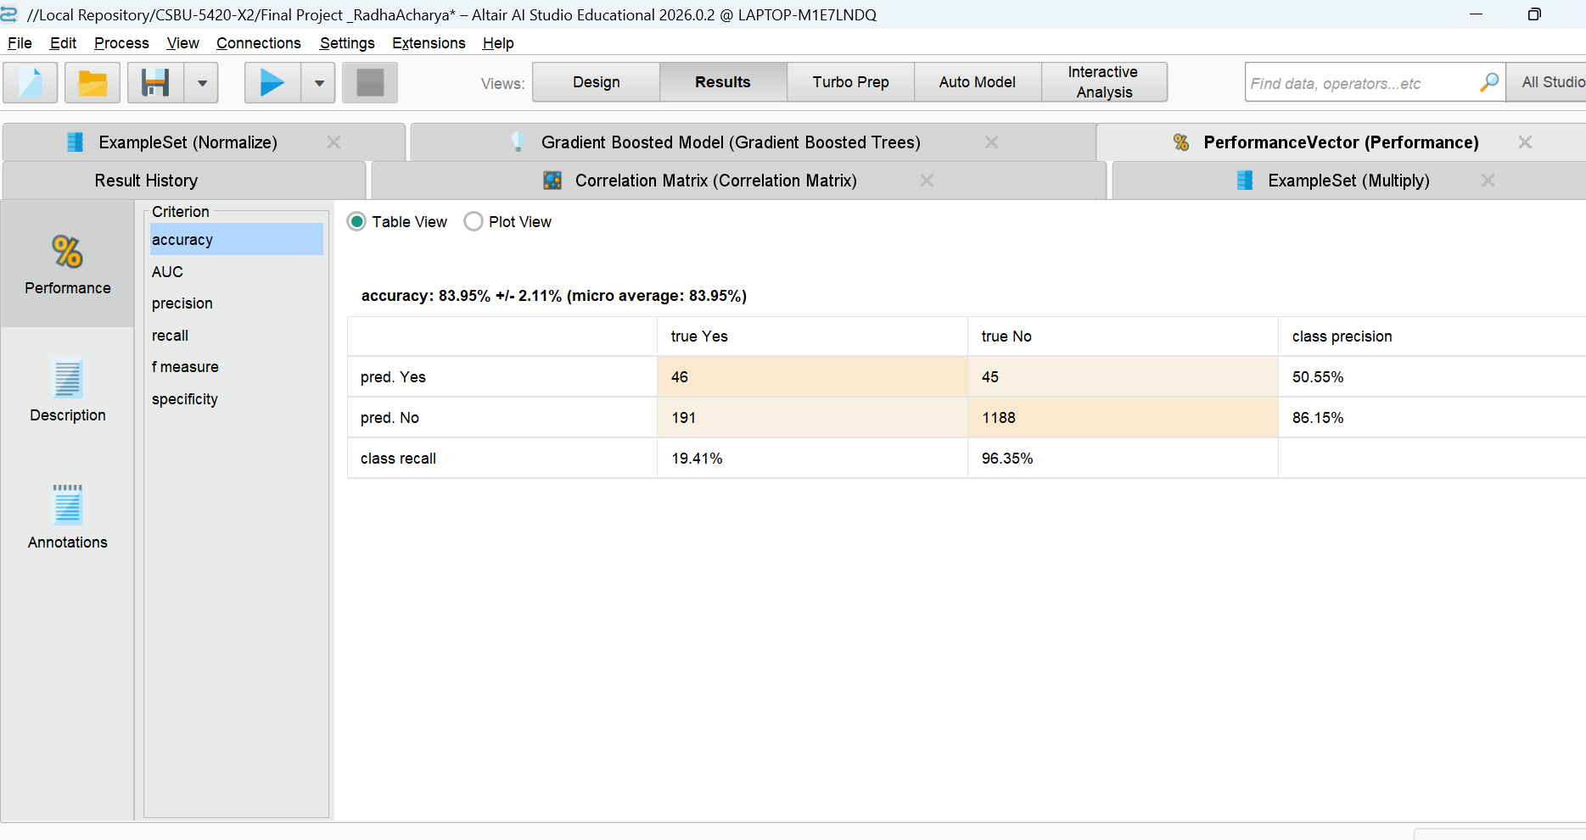
The Gradient Boosting model has an accuracy of 83.95 % which means that it can classify the number of employees who left the company with a recall of 19.41 %. On the other hand, the model also obtains good results while predicting employee who stayed in the company with a recall of 96.35 % for the No class. At the same time, it still indicates certain level of sensitivity in the detection of actual attrition. Overall, in comparison with other models Gradient boosting model shows better results in the detection of employees at risk and this model is one of the better models among all.

AUC AND ROC
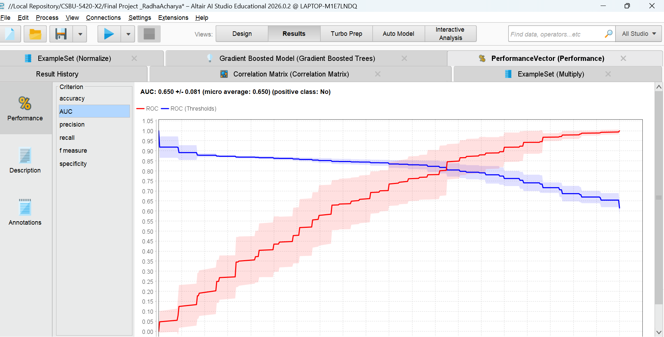 The Gradient Boosting model has an AUC of 0.650 which has a moderate predicting ability. The ROC curve performs better than Random Guessing although it does not have strong ability to distinguish employees who are staying and who are leaving the organization. Gradient Boosting model gives reasonable predictions for employee turnover in comparison with other models, and it still has room for improvement.

PERFORMANCE EVALUATION
Model | Accuracy (%) | Recall (Yes) | Precision (Yes) | AUC | Strength | Weakness
Logistic Regression | 84.22% | 10.55% | 55.56% | 0.69 | High overall accuracy | Low attrition detection
LDA | 84.08% | 1.69% | 84.10% | 0.000 | Strong majority prediction | Extremely poor minority recall
KNN | 82.38% | 16.03% | 85.51 | 0.617 | Better minority sensitivity | Limited discrimination power
Naïve Bayes | 84.01% | 16.88% | 51.28% | 0.690 | Balanced baseline model | Moderate attrition detection
Random Forest (Bagging) | 83.74% | 6.75% | 47.06% | 0.681 | Stable ensemble method | Biased toward majority class
Gradient Boosting | 83.95% | 19.41% | 50.55% | 0.650 | Best attrition detection | Moderate overall discrimination

While all the models performed with comparable accuracy (82-84%), there were significant differences regarding the detection of minority classes. The highest recall was observed with the Gradient Boosting model for the class of employees who left the company (19.41%), making it the best model for employee attrition prediction. However, the aim and scope of the present study were focused on identifying the employees who were at risk; therefore, recall for the 'Yes' class was given more importance than the overall accuracy.

BUSINESS INSIGHTS
The factors that influence employee attitude according to above analysis are:
- Less monthly income is the greater probability of employees’ turnover.
- Carrer growth is also another factor for employee attrition
- Similarly, overtime is also another factor for employee attrition.
- Tenure is also another factor for employee attrition as shorter the tenure greater the probability of employee attrition.

CONCLUSION
Overall, the project used various supervised machine learning models to predict employee attrition using the IBM HR dataset. Even though all the models performed equally in predicting employee attrition, Gradient Boosting Model is good at predicting who left the organization and the model is the best model to use in a proactive approach in decision making in the field of HR.
Even though employees leave the job due to various reasons such as overtime, compensation, tenure, job role, organization can use predictive analytics to move from reactive to a proactive approach to managing employees by cutting costs on employee turnover.

RECOMMENDATIONS
Based on the findings the organization should consider following recommendations:
- Designed structure promotions plans
- Monitoring overtime levels and reducing overtime
- Periodic compensation benchmarking
- Companies can provide mentorship programs for new employees.
- Organization can change from reactive turnover management to proactive employee retention along with predictive analytics.

APPENDICES

DETAILED CALCULATIONS
Detailed Calculation Include
- Accuracy
Accuracy = (TP+TN) / (TP+TN+FP+FN)
- Precision
Precision = TP / (TP+FP)
- Recall (Sensitivity)
Recalled = TP/ (TP + FN)

REFRENCES
IBM HR Analytics Employee Attrition & Performance Dataset. (2016). Kaggle. https://www.kaggle.com/datasets/pavansubhasht/ibm-hr-analytics-attrition-dataset

